Wentworth Institute of Technology

2D Chess

Project Design Document

Team: Indecisive

Tiffany Phan and Yuliya Smilyanova

[phant9@wit.edu](mailto:phant9@wit.edu) and [smilyanovay@wit.edu](mailto:smilyanovay@wit.edu)

GitHub Repo: <https://github.com/smilyanovayatwit/2D_Chess>

**Table of Contents**

1. Introduction……………………………………………………………………………………………………………………………..3

2. Application Features…………………………………………………………………………………………………………………3

3. Application Architecture…………………………………………………………………………………………………………..3

4. System Design………………………………………………………………………………………………………………………….3

5. Plan………………………………………………………………………………………………………………………………………….5

6. References……………………………………………………………………………………………………………………………….5

**1. Introduction**

2D Chess is a console network application of the popular two player board game, chess, consisting of chess server and two clients. Developing this application allows is a great way to practice, play around, and master socket programming and multithreading and a great way to understand how the game of chess is played. One of the unique features of this application is that you can have different colors for the chess pieces and board instead of the original black and white colors.

**2. Application Features**

* Allow client to join a game
* Allow client to choose a color (white or black) if they are the first one, otherwise be given the remaining color
* Allow client to leave the game

**3. Application Architecture**

This chess game application is server-client architecture applied to a regular chess game (multiplayer purposes).

Chess Game: Board, players, board color, all the pieces for the game

Server: Multithreaded, can handle multiple clients at the same time, only 2 clients per game

Client: Multithreaded, can receive messages from the server, can send messages to the server

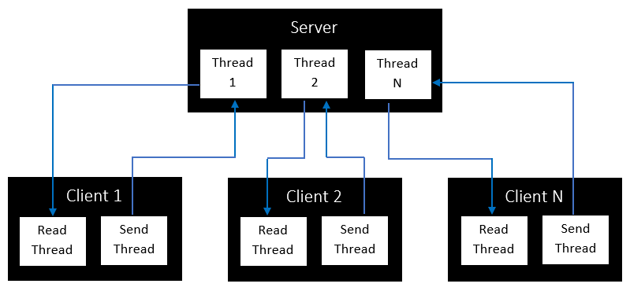

**4. System Design**

Allow client to join a game and choose a color/be given a color

* Client 1 connects to Server
* Server accepts connection and sends welcome message
* If there is a Client 2, Server notifies them of Client 1 joining the game

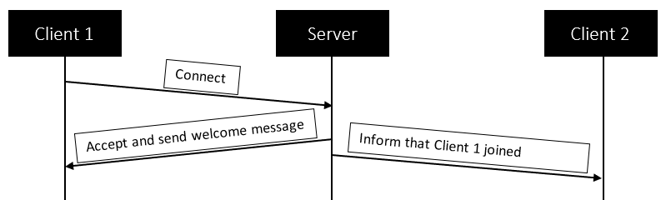

Allow client to choose a color (white or black) if they are the first one, otherwise be given the remaining color

* If Client 1 is the first player, Server asks them to choose a color (white or black) after the welcome message
* Client 1’s response is sent to the Server
* Server sends response message with the color they chose
* When Client 2 joins, Server sends a message after the welcome message with the color that is left, which is their color

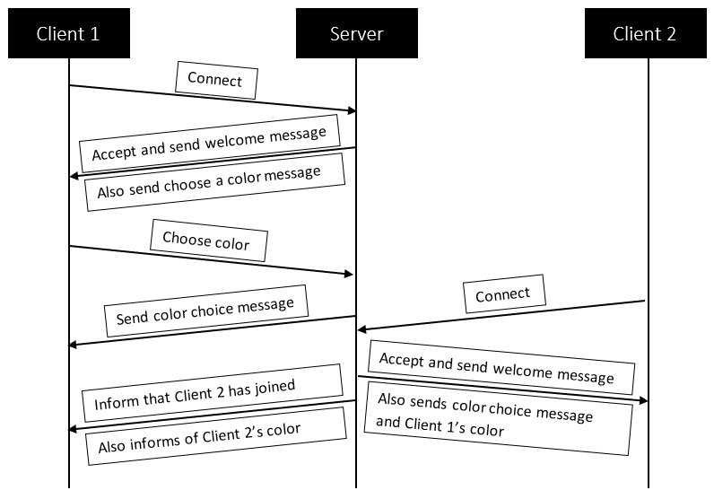

Allow client to leave the game

* Client 1 sends {quit} message
* Server closes the connection with Client 1
* Server notifies Client 2 that Client 1 left

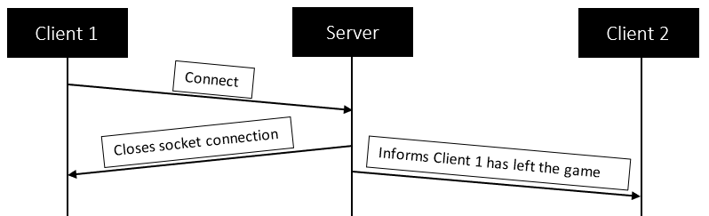

**5. Plan**

|  |  |  |  |  |
| --- | --- | --- | --- | --- |
| Week | Feature | Task | Assign To | Done By |
| Week 9 | Chess Game | * Implement the chess game | Yuliya | Week 11 |
| Week 11 | Server-Client Interaction | * Implement the multithreaded server * Allow client to join a game * Allow client to choose a color (white or black) if they are the first one, otherwise be given the remaining color * Allow client to leave the game | Tiffany | Week 12 |
| Week 11 | Server-Client Interaction | * Allow client to make a move * Server notifies client of the winner | Yuliya | Week 12 |
| Week 12 | Final Presentation | * Powerpoint Presentation | Team | Week 13 |
| Week 13 | Final Report | * Demo video |  | Week 14 |

**6. References**

* <https://web.cs.wpi.edu/~imgd4000/d07/projects/proj3/proj3.pdf>
* <https://www.youtube.com/watch?v=yyhNBV_5ayM>
* <https://www.youtube.com/watch?v=Bj6N0pEVC-I>
* <https://massivetechinterview.blogspot.com/2015/07/design-chess-game-using-oo-principles.html>
* <https://medium.com/analytics-vidhya/school-java-project-chess-1-85f97a2d1877>
* <http://www.java2s.com/example/java/2d-graphics/draw-a-chess-board.html>
* <https://www.openprocessing.org/sketch/309165/>
* [https://www.geeksforgeeks.org/design-a-chess-game/](https://nam04.safelinks.protection.outlook.com/?url=https%3A%2F%2Fwww.geeksforgeeks.org%2Fdesign-a-chess-game%2F&data=04%7C01%7Cphant9%40wit.edu%7C7876c08273e145d5fcfa08d88a5243b9%7C2af16cc576494528bc4d3d9b6f64c066%7C0%7C0%7C637411433235762309%7CUnknown%7CTWFpbGZsb3d8eyJWIjoiMC4wLjAwMDAiLCJQIjoiV2luMzIiLCJBTiI6Ik1haWwiLCJXVCI6Mn0%3D%7C1000&sdata=syQlznFmJ3%2F6QyuWIPmpPHAlRyJsV1wIX%2F%2F832T6tDE%3D&reserved=0)
* [https://codemiles.com/finished-projects/java-chess-t618.html?mobile=on](https://nam04.safelinks.protection.outlook.com/?url=https%3A%2F%2Fcodemiles.com%2Ffinished-projects%2Fjava-chess-t618.html%3Fmobile%3Don&data=04%7C01%7Cphant9%40wit.edu%7C7876c08273e145d5fcfa08d88a5243b9%7C2af16cc576494528bc4d3d9b6f64c066%7C0%7C0%7C637411433235772264%7CUnknown%7CTWFpbGZsb3d8eyJWIjoiMC4wLjAwMDAiLCJQIjoiV2luMzIiLCJBTiI6Ik1haWwiLCJXVCI6Mn0%3D%7C1000&sdata=yx%2FVyQnVpsM7ZyCR6Z3quJ1TavGQFOMXIhqMaCk5sTc%3D&reserved=0)